DYSLEXIA INFORMATION FOR PARENTS
What Is Dyslexia?
There are several definitions of Dyslexia. Dyslexia might best be described as an unexpected difficulty learning to read. Students identified with the disability of dyslexia often are described to struggle with phonology (the recognition and manipulation of sounds) in language. Students with dyslexia my affect a child’s ability to decode words — to break them down into constituent sounds, or phonemes, and then to sound out novel words. That process may make it hard to recognize words, to retrieve words, to read, to write and to spell.

According to the Texas Education Agency’s (TEA’s) Dyslexia Handbook, the student who struggles with reading and spelling often puzzles teachers and parents. The student that displays the ability to learn in the absence of print and receives the same classroom instruction that benefits most children; however, the student continues to struggle with some or all of the many facets of reading and spelling. This student may be a student with dyslexia.
Texas Education Code (TEC) §38.003 defines dyslexia and related disorders in the following way:

“Dyslexia” means a disorder of constitutional origin manifested by a difficulty in learning to read, write, or spell, despite conventional instruction, adequate intelligence, and sociocultural opportunity. “Related disorders” include disorders similar to or related to dyslexia, such as developmental auditory imperception, dysphasia, specific developmental dyslexia, developmental dysgraphia, and developmental spelling disability.”
TEC §38.003(d)(1)-(2) (1995)
The International Dyslexia Association defines “dyslexia” in the following way:
“Dyslexia is a specific learning disability that is neurobiological in origin. It is characterized by difficulties with accurate and/or fluent word recognition and by poor spelling and decoding abilities. These difficulties typically result from a deficit in the phonological component of language that is often unexpected in relation to other cognitive abilities and the provision of effective classroom instruction. Secondary consequences may include problems in reading comprehension and reduced reading experience that can impede growth of vocabulary and background knowledge.”

Adopted by the International Dyslexia Association Board of Directors, November 12, 2002:
“Students identified as having dyslexia typically experience primary difficulties in phonological awareness, including phonemic awareness and manipulation, single-word reading, reading fluency, and spelling. Consequences may include difficulties in reading comprehension and/or written expression. These difficulties in phonological awareness are unexpected for the student’s age and educational level and are not primarily the result of language difference factors. Additionally, there is often a family history of similar difficulties.”

What are the characteristics of Dyslexia?
The following information is outlined in the Texas Education Agency’s (TEA’s):
- The following are the primary reading/spelling characteristics of dyslexia:
• Difficulty reading words in isolation
• Difficulty accurately decoding unfamiliar words
• Difficulty with oral reading (slow, inaccurate, or labored without prosody)
• Difficulty spelling It is important to note that individuals demonstrate differences in degree of impairment and may not exhibit all the characteristics listed above.

- The reading/spelling characteristics are most often associated with the following:
• Segmenting, blending, and manipulating sounds in words (phonemic awareness)
• Learning the names of letters and their associated sounds
• Holding information about sounds and words in memory (phonological memory)
• Rapidly recalling the names of familiar objects, colors, or letters of the alphabet (rapid naming)
- Consequences of dyslexia may include the following:
• Variable difficulty with aspects of reading comprehension
• Variable difficulty with aspects of written language
• Limited vocabulary growth due to reduced reading experiences

Information on Testing of Dyslexia and Related Disorders, eligibility, and Services Available Under IDEA and the Rehabilitation Act, Section 504, and Information on the Response to Intervention Process:
State Requirements In 2017, the 85th Texas Legislature passed House Bill (HB) 1886, amending Texas Education Code (TEC) §38.003, Screening and Treatment for Dyslexia. School districts in Texas are required to:
- All kindergarten and first-grade public school students be screened for dyslexia and related disorders. Additionally, the law requires that all students beyond first grade be screened or tested as appropriate. In response to the screening requirements of HB 1886, the SBOE amended its rule in 19 Texas Administrative Code (TAC) §74.28, Students with Dyslexia and Related Disorders. While this rule speaks primarily to evaluation and identification of a student with dyslexia or related disorders, it also requires that evaluations only be conducted by appropriately trained and qualified individuals.
- A related state law adds an additional layer to screening requirements for public school students. Texas Education Code §28.006, Reading Diagnosis, requires each school district to administer to students in kindergarten, first grade, and second grade a reading instrument to diagnose student reading development and comprehension. This law also requires school districts to administer a reading instrument at the beginning of seventh grade to students who did not demonstrate reading proficiency on the sixth-grade state reading assessment. The law requires each school district to administer to kindergarten students a reading instrument adopted by the commissioner, or an alternative reading instrument approved by the commissioner. Districts are permitted to use reading instruments other than those adopted by the commissioner for first, second, and seventh grades only when a district-level committee adopts these additional instruments.
- Texas Education Code §28.006(d) requires each district to report the results of these reading instruments to the district’s board of trustees, TEA, and the parent or guardian of each student. Further, a school district is required to notify the parent or guardian of each student in kindergarten, first grade, or second grade who is determined to be at risk for dyslexia or other reading difficulties based on the results of the reading instruments.
- Federal Requirements- Child Find In addition to state and local requirements to screen and identify students who may be at risk for dyslexia, there are also overarching federal laws and regulations to identify students with disabilities, commonly referred to as Child Find. Child Find is a provision in the Individuals with Disabilities Education Act (IDEA), a federal law that requires the state to have policies and procedures in place to ensure that every student in the state who needs special education and related services is located, identified, and evaluated. The purpose of the IDEA is to ensure that students with disabilities are offered a free and appropriate public education (20 U.S.C. §1400(d); 34 C.F.R. §300.1). Because a student suspected of having

dyslexia may be a student with a disability under the IDEA, the Child Find mandate includes these students. Therefore, when referring and evaluating students suspected of having dyslexia, LEAs must follow procedures for conducting a full individual and initial evaluation (FIIE) under the IDEA.

Another federal law that applies to students with disabilities in public school is Section 504 of the Rehabilitation Act of 1973, commonly referred to as Section 504. Under Section 504, public schools must annually attempt to identify and locate every qualified student with a disability residing in its jurisdiction and notify them and/or their parents of the requirements of Section 504.

The following is a flowchart outlining the pathways for the identification and provision of instruction for students with dyslexia:

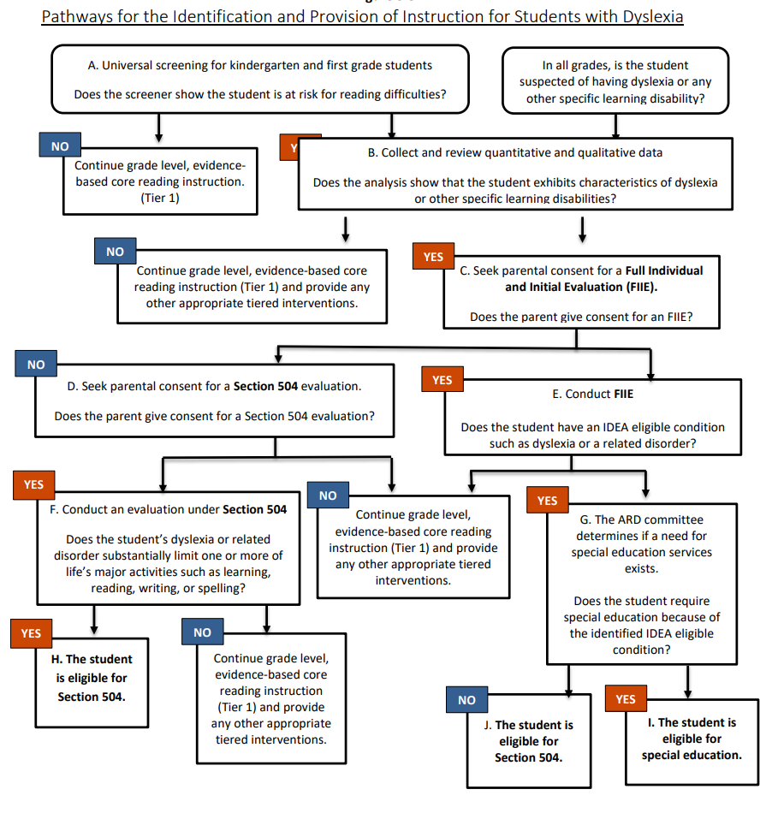

Information on effective strategies for teaching students with dyslexia and related disorders:
Effective literacy instruction is essential for all students and is especially critical for students identified with dyslexia. High-quality core classroom reading instruction can give students identified with dyslexia a foundation upon which intervention instruction can have a more significant impact.

Texas Education Code §38.003(b) states, “in accordance with the program approved by the State Board of Education, the board of trustees of each school district shall provide for the treatment of any student determined to have dyslexia or a related disorder.” SBOE rules in 19 TAC §74.28 require that each school must provide an identified student access at his/her campus to an instructional program that meets the requirements in SBOE rule and to the services of a teacher trained in dyslexia and related disorders. While the components of instruction for students with dyslexia include good teaching principles for all teachers, the explicitness and intensity of the instruction, fidelity to program descriptors, grouping formats, and training and skill of the teachers are wholly different from core classroom instruction and must be considered when making individual placement decisions.

Standard Protocol Dyslexia Instruction For the student who has not benefited from the research-based core reading instruction, the components of instruction will include additional focused intervention as appropriate for the reading needs of the student with dyslexia. Standard protocol dyslexia instruction provides evidence-based, multisensory structured literacy instruction for students with dyslexia. A standard protocol dyslexia instructional program must be explicit, systematic, and intentional in its approach. This instruction is designed for all students with dyslexia and will often take place in a small group setting. Standard protocol dyslexia instruction must be—
- evidence-based and effective for students with dyslexia;
- taught by an appropriately trained instructor; and
- implemented with fidelity. Instructional decisions for a student with dyslexia must be made by a committee (Section 504 or ARD) that is knowledgeable about the instructional components and approaches for students with dyslexia.

It is important to remember that while dyslexia instruction is most successful when provided as early as possible, older children with reading disabilities will also benefit from focused and intensive remedial instruction. In accordance with 19 TAC §74.28(e), districts must purchase or develop an evidence-based reading program for students with dyslexia and related disorders that incorporates all the components of instruction and instructional approaches described in the sections below.

As is the case with any instructional program, 40 differentiation that does not compromise the fidelity of a program may be necessary to address different learning styles and ability levels and to promote progress among students receiving dyslexia instruction. While districts and charter schools must implement an evidence-based instructional program for students with dyslexia that meets each of the components described in this chapter, standard protocol dyslexia instruction provided to students may focus on components of the program that best meet the student’s needs. For example, this may occur when a student with dyslexia who has participated in standard protocol dyslexia instruction in the past, but continues to need remediation in some, but not all of, the components (e.g. fluency, written expression). Specially Designed Instruction For students with dyslexia who have been determined eligible for and who are receiving special education services, specially designed instruction must also address the critical, evidence-based components

described in this chapter. Specially designed instruction differs from standard protocol dyslexia instruction in that it offers a more individualized program specifically designed to meet a student’s unique needs. Note that participation in standard protocol dyslexia instruction must be considered for all students, including those receiving dyslexia instruction under the IDEA. Standard protocol dyslexia instruction could be part of the specially designed instruction and services provided to meet the student’s needs.

How to Help Kids With Dyslexia:
Fortunately, there are evidence-based supports to help children with dyslexia improve their reading skills. A program appropriate to a child with dyslexia might include these features:
- Multi-sensory instruction in decoding skills Repetition and review of skills Intensity of intervention
- Small group or individual instruction
- Teaching phonological skills Drilling sight words
- Teaching comprehension strategies, to help kids derive meaning from what they’re reading

Dr. Cruger adds that an important part of supporting kids with dyslexia is finding ways to decrease their discomfort about reading, and to make learning to read enjoyable, not humiliating. That means minimizing the amount of time you spend correcting the child and maximizing encouragement of even small gains.

Accommodations for Kids With Dyslexia:
Children who have dyslexia are entitled to accommodations that enable them to learn — and demonstrate their learning — despite their reading challenges.

Accommodations can include:
- Extra time on tests
- A quiet space to work
- The option to record lectures
- The option to give verbal, rather than written, answers (when appropriate)
- Elimination of oral reading in class
- Exemption from foreign language learning
- Encourage the things the student enjoys and excels at, so that they feel confident in some areas. This could be sports, theater, art, science, debate team or anything else that makes the child feel good at something.
- Sharing stories of successful individuals with dyslexia might also help reinforce that it has nothing to do with intelligence.
- Supportive tools and technology can help your child navigate difficult problems:
  - Audio books can be a great alternative to reading
  - Typing on a computer or tablet instead of writing
  - Apps that can help make learning fun by turning phonological awareness into a game
  - Old-fashioned rulers can help kids with dyslexia read in a straight line, which might help keep them focused

Instructional Accommodations for Students with Disabilities:
Students with dyslexia who receive dyslexia instruction that contains the components outlined will be better equipped to meet the demands of grade-level or course instruction. In addition to dyslexia instruction, accommodations provide the student with dyslexia effective and equitable access to grade-level or course instruction in the general education classroom. Accommodations are not one size fits all; rather, the impact of dyslexia on each individual student determines the necessary accommodation.

Listed below are examples of reasonable classroom accommodations:
- Copies of notes (e.g., teacher- or peer-provided)
- Note-taking assistance
- Additional time on class assignments and tests
- Reduced/shortened assignments (e.g., chunking assignments into manageable units, fewer items given on a classroom test or homework assignment without eliminating concepts, or student planner to assist with assignments)
- Alternative test location that provides a quiet environment and reduces distractions
- Priority seating assignment
- Oral reading of directions or written material
- Word banks
- Audiobooks
- Text to speech
- Speech to text
- Electronic spellers
- Electronic dictionaries
- Formula charts
- Adaptive learning tools and features in software programs

Accommodations are changes to materials, actions, or techniques, including the use of technology, that enable students with disabilities to participate meaningfully in grade-level or course instruction. The use of accommodations occurs primarily during classroom instruction as educators use various instructional strategies to meet the needs of each student. A student may need an accommodation only temporarily while learning a new skill, or a student might require the accommodation throughout the school year and over several years including beyond graduation.

Decisions about which accommodations to use are very individualized and should be made for each student by that student’s ARD or Section 504 committee, as appropriate. Students can, and should, play a significant role in choosing and using accommodations. Students need to know what accommodations are possible, and then, based on knowledge of their personal strengths and limitations, they select and try accommodations that might be useful for them. The more input students have in their own accommodation choices, the more likely it is that they will use and benefit from the accommodations. When making decisions about accommodations, instruction is always the foremost priority. Not all accommodations used in the classroom are allowed during a state assessment. However, an educator’s ability to meet the individual needs of a student with dyslexia or provide support for the use of an accommodation should not be limited by whether an accommodation is allowable on a state assessment.

In order to make accommodation decisions for students, educators should have knowledge of the Texas Essential Knowledge and Skills (TEKS) and how a student performs in relation to them. Educators should also collect and analyze data pertaining to the use and effectiveness of accommodations (e.g., assignment/test scores with and without the accommodation, observational reports from parents and teachers) so that informed educational decisions can be made for each student. By analyzing data, an educator can determine if the accommodation becomes inappropriate or unnecessary over time due to the student’s changing needs. Likewise, data can confirm for the educator that the student still struggles in certain areas and should continue to use the accommodation

Providers of Dyslexia Instruction:
In order to provide effective intervention, school districts are encouraged to employ highly trained individuals to deliver dyslexia instruction. Teachers, such as reading specialists, master reading teachers, general education classroom teachers, or special education teachers, who provide dyslexia intervention for students are not required to hold a specific license or certification. However, these educators must at a minimum have additional documented dyslexia training aligned to 19 TAC §74.28(c) and must deliver the instruction with fidelity. This includes training in critical, evidence-based components of dyslexia instruction such as phonological awareness, sound-symbol association, syllabication, orthography, morphology, syntax, reading comprehension, and reading fluency. In addition, they must deliver multisensory instruction that simultaneously uses all learning pathways to the brain, is systematic and cumulative, is explicitly taught, uses diagnostic teaching to automaticity, and includes both analytic and synthetic approaches.

A provider of dyslexia instruction does not have to be certified as a special educator when serving a student who also receives special education and related services if that provider is the most appropriate person to offer dyslexia instruction. Although Texas does not have a certification requirement specific to teachers providing intervention to students with dyslexia, opportunities for those who provide dyslexia instruction to pursue a certification and/or license are available through several professional organizations as well as through the Texas Department of Licensing and Regulation.

Contact Information for the Relevant Regional and/or School District Specialists:
- Darla G. Peter, TCEC Executive Director
325-437-8232 or dpeter@tcec.us

Resources:
If you have any questions regarding the reading/dyslexia difficulties, you may contact the district’s Dyslexia Coordinator at the information listed below:

Additional information can be found in the Dyslexia Handbook.
The link for accessing the Dyslexia Handbook can be found on the TCECs website (https://www.tcec-ssa.com/) or listed below.
- Dyslexia Handbook Website Link:
https://tea.texas.gov/sites/default/files/texas-dyslexia-handbook-2021.pdf
- Texas State Library and Archives Commission (TSLAC) Website Link:
https://www.tsl.texas.gov/tbp/index.html

